

THE UNIVERSITY OF AZAD JAMMU AND KASHMIR
DEPARTMENT OF SOFTWARE ENGINEERING

ASSIGNMENT 01 OF GRAPHICS DESIGNING

SUBMITTED TO: MAM FATIMA
SUBMITTED BY: TAYABA NOOR
ROLL NO #2024-SET-40
COURSE CODE: ST-2205
4RTH SEMESTER (2024-28)
DATE: 14-04-2026

DESIGN

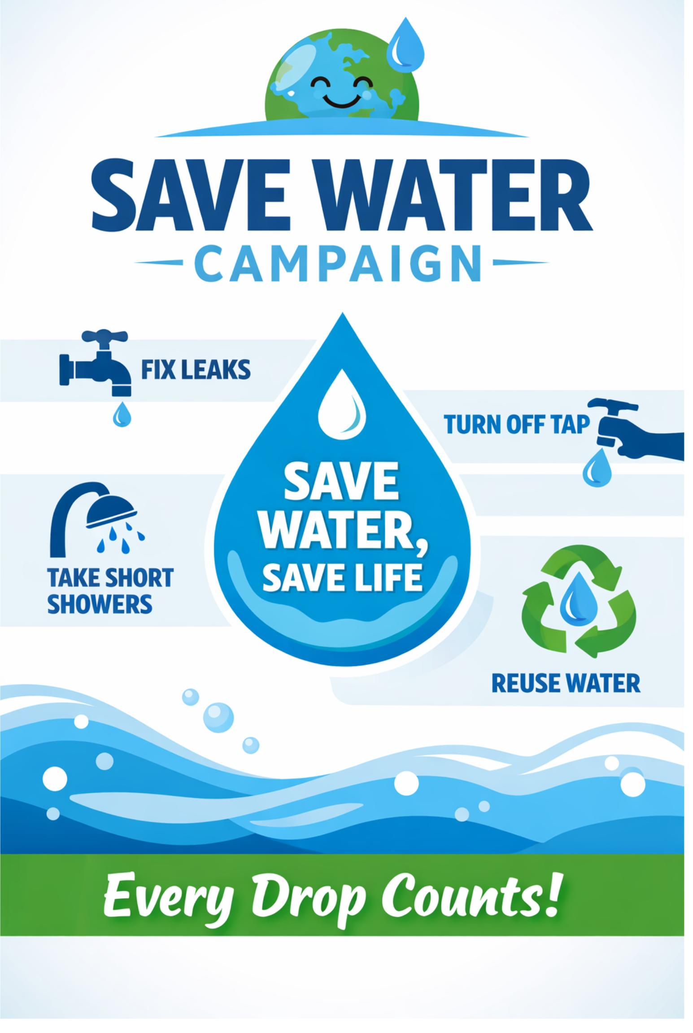

EXPLAINATION:
I Designed this poster on the Save Water Campaign using a simple and clean layout. I selected blue, green, and white colors because they represent water, nature, and cleanliness. Blue highlights the importance of water, while green symbolizes environmental protection. White keeps the design neat and improves readability.
For typography, I used bold and clear fonts to make the title stand out and attract attention. A simple, readable font is used for the supporting text so that the message is easy to understand at a glance. I limited the design to two fonts to maintain consistency and avoid clutter. Icons and shapes are included to visually represent key actions like fixing leaks and turning off taps. Overall, the poster is balanced, visually appealing, and effectively communicates the message of saving water.

